TOASTMASTERS INTERNATIONAL DISTRICT 17
HUMOROUS SPEECH CONTEST
CONTEST CHAIR SCRIPT TO CONTESTANTS
Online Contest 2022
This briefing can be conducted up to 24 hours prior to the contest using the platform (Zoom) that will be in use for the contest.
This contest is in accordance with Toastmasters International Contest Rule Book 2021-2022 and TI Online Speech Contest Best Practices 2021 – 2022 Toastmasters Contest Cycle
Before the Contestant Briefing
- Ensure the Timers are on-line for the contestant briefing to show timing and to be briefed on the process if there is an equipment failure.
- Ensure that you have a method to determine the speaking order (e.g. wheelofnames.com^{#3}).
- Check all contestants are eligible to compete and that you have received the Eligibility and Originality forms.
- Check that you have received the speech titles and their completed Speech Contestants Profile (Bio) for conducting contestant interview.
- Ensure you have read the Item 479 from TI – Online Speech Contest Best Practice (this is recommended reading for all role players and contestants).
- Seek advice from Chief Judge for timing of contestant reconnection in case of technology failure.^{#2}
- Ensure you have participation certificates (provide to Zoom Master).
- Ensure you have winner and place getter certificates (provided to Zoom Master).
Contestant Briefing
Contestants welcome to the Area xx/ Division xx / District 17 Humorous Speech Contest 2022.
We will now draw the speaking order. Draw the speaking order ^{#3}- using the method chosen.
Contestant number one will be
Contestant number two will be
Contestant number three will be
Contestant number four will be
Contestant number five will be
Contestant number six will be
Zoom Master 2 should have been instructed to come into the briefing room to collect speaking order to provide to Chief Judge. If they don’t appear, text the Zoom Master.
I will now like you to demonstrate your speaking area.
While all contestants will be speaking in their own space, using their own technology, the speaking area should be set to roughly the same size for each contestant. When setting speaking area, the goal is to maximize the view of the contestants without sacrificing audio quality. (TI Item 479 Online Speech Contest Best Practice).
District contest only: Ensure rule book criteria are met regarding lighting audio and speaking area.
Once the speaking areas are roughly the same size, you can continue with the briefing.
You will need to advise the Chief Judge on how the speaking area was defined, for them to pass onto the other judges. This can be done by text to the Chief Judge.
Contestant Props
Please advise if you are using props.^{#5}
If anyone is using props: Please ensure that your props are set up in the one minute silence prior to you being introduced. If you can not set up your props in this time they may not be used.
Contestants Video and Microphone^{#4}
Your video and microphone is to remain off / mute unless you are speaking or unless asked by the Contest Chair to switch on.
Protests
Protests are limited to eligibility, originality and referencing another contest speaker’s speech. Protests need to be lodged with myself or the Chief Judge. If you wish to lodge a protest, please text/sms me or the Chief Judge prior to the announcement of the results. Ensure contestants have your phone number.
As a protestor you will be called to the Judges room to show evidence of your protest. The contestant will be interviewed by the Judges to determine if the protest will be upheld. The Judges will determine if the protest is valid.
Disqualifications
Contestants will be disqualified if they speak less than 4 minutes 30 seconds or more that 7 minutes 30 seconds.
Please ensure you know how to pin the Timer or hide non-video participants. Provide details on this if necessary. ^{#6}
Timer, could we please have a display of the timing lights. Timer to demonstrate timing lights while Contest Chair reads the following.
Timing will be begin with the first definite verbal or non-verbal communication. The green signal will be displayed at 5 minutes and remain on until the 6 minute mark and be replaced by an amber signal which will remain on until the 7 minute mark and be replaced by a red signal. This will remain on until the conclusion of your speech.
Thank you, Timer.
When you are introduced for your speech, I will ask you to respond verbally to ensure that your mic is on and that you can see the Timer.
I will then introduce you in the format - your name, your speech title, your speech title and your name again. At this point you should start your presentation without delay.
On completion of your speech, please turn off your video and microphone.
If your (contestant’s) system drops out during your presentation:
- Timers will take note of the time, of system failure.
- Timer 1 will display the neutral colour while you attempt to reconnect. At the conclusion of the Chief Judges ruling, if you have not reconnected, the Timer will display the red.
- If you do reconnect within the specified time, the Timer will change the timing colour to the colour it was on when you dropped out and continue timing as per the standard timing convention.
- You will need to resume your speech where you left off. I will provide you with the last word(s) that I recall when you were disconnected^{#2}. You can then recommence your speech and the timing will restart from that point.
- If you drop out again and cannot reconnect the Chief Judge will determine if your speech is considered concluded and the time will be recorded at that point. If you do reconnect follow the instructions, I have already discussed
If the timing signal system (Timer 1) drops out during your presentation look for Timer 2 who will take over the timing system. Should there by an interruption caused by a timing malfunction an extra 30secs will be allowed for in your speech timing.
You may record your own speeches, please ensure that this recording can be done without substantially disrupting the contest.
On completion of the contest you will be asked to turn your video on. You will be presented with your participation certificate and then I will conduct interviews using the information on your Bio. During this time, please turn your microphone off unless answering a question.
This concludes the briefing. Do you have any questions?

This is not to be read to the Contestants, and is only included for the information of the Contest Chair, Chief Judge and other interested parties.
Explanations of Script:
Non spoken information and explanations in red
Information based on choice is in green.
References and TI Best Practice Details:
The following are to be read in conjunction with Toastmasters International Speech Contest Rules and TI Online Speech Contest Best Practices 2021 – 2022 Toastmasters Contest Cycle
#1 Contestant eligibility
Eligibility form is to be downloaded by contestant, signed, photographed, and sent to the contest chair and Chief Judge from their personal message service which will identify them as the sender. For the International speech contest:- already competed 6 Competent Communicator speeches or have certificates for completing level 1 and level 2 of any path.
The contestants must be in good standing from a club in good standing.
#2 Chief Judge to determine time duration for contestant to reconnect. For consistency 3 minutes have been recommended for this speech cycle.
Decide how you plan to respond should a technology issue cause a contestant or official
to lose connection during the contest. It is recommended that the chief judge pause the contest to provide opportunity for the contestant or official to regain connection.
- The chief judge decides how long the contest should be paused for in the event of a technical issue.
- The chief judge must communicate this decision to all contestants and contest officials prior to the start of the contest.
- The chief judge is responsible for pausing the contest.
- Determine ahead of time how the decision to pause will be communicated.
• It is recommended that all contest officials have a means of communicating with the chief judge. If a contest official cannot hear or see a contestant, they should contact the chief judge immediately.
- If a contestant loses connection during the contest but is able to regain connection, they should pick up their speech at the point where they left off. The contest chair can indicate the last word or sentence that was heard so they know where they lost connection.
If a contest official loses connection and you have a backup official to take their place, confirm the process for communicating with the backup official that they are needed.
#3 Draw random selection
Wheel of names, is an easy and visible way to select speaking order -https://wheelofnames.com/
Under Customize do the following to ensure a speedy process:
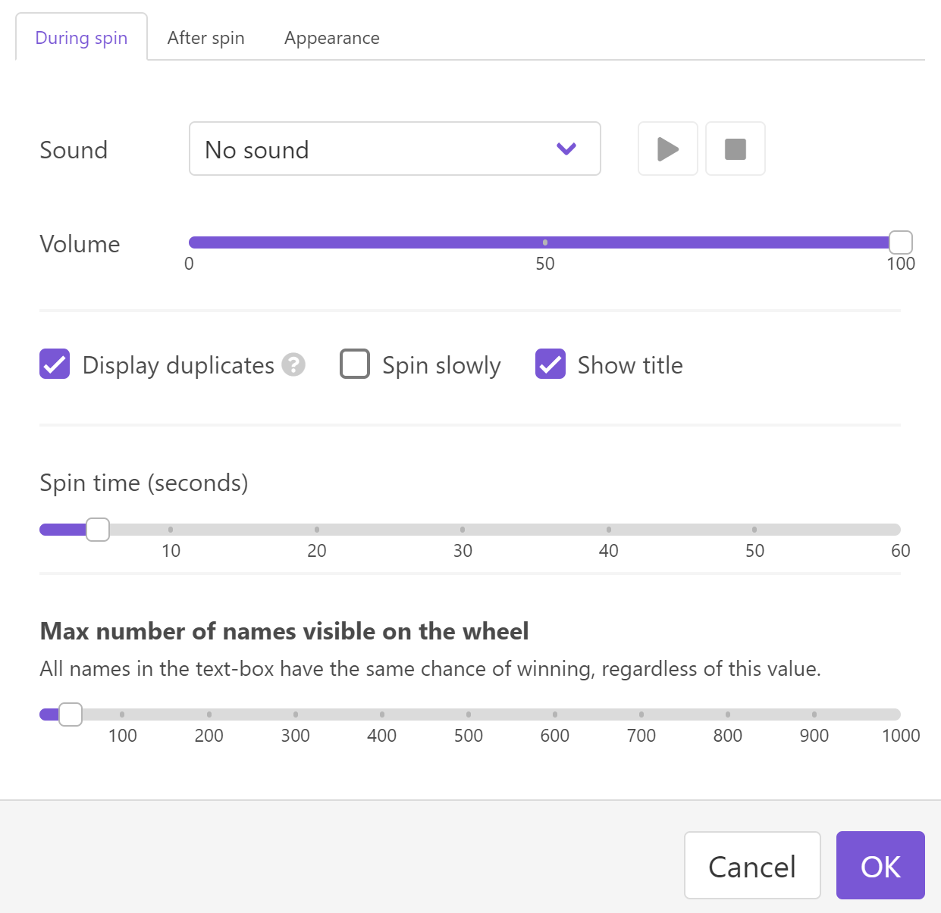 | 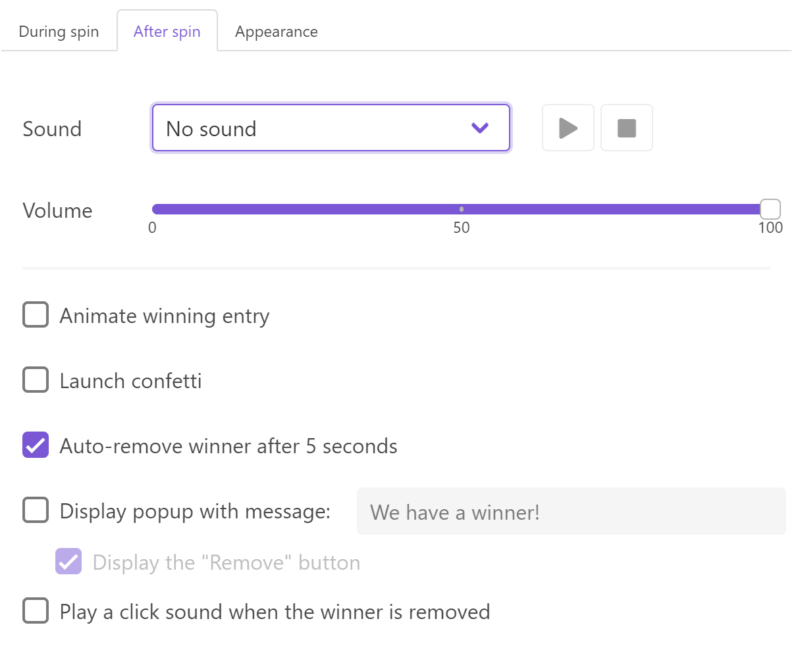

#4 Webcams turned off Microphones muted at all times.
Webcams can slow down internet band width and distract some contestants.
Although laughter and verbal reactions from audience members are often welcome in a speech contest microphones in an online speech contest setting will also pick up distracting background audio.
#5 Props
Contestants who plan to use props (including any sort of electronic devices) must notify the contest chair prior to the contest. Plus comply with 1 minute set up (Contest Rule Book)
#6 Pin Timer
Using the 3 small dots at the top of your photo pin timer. At the bottom of the screen there is the word Video and a small arrow alongside it . Click on the arrow and pin the timer
Ipad double tap screen.

