Contest Opening Remarks by Zoom Master 2 / Contest SAA

Information – Script is on next page
From Toastmasters International Online Speech Contest Best Practices document:
Because your contest is being held on an online platform, you will need to read the online speech contest statement at the start of your contest or include it in writing in a location that will be visible to all attendees and participants.
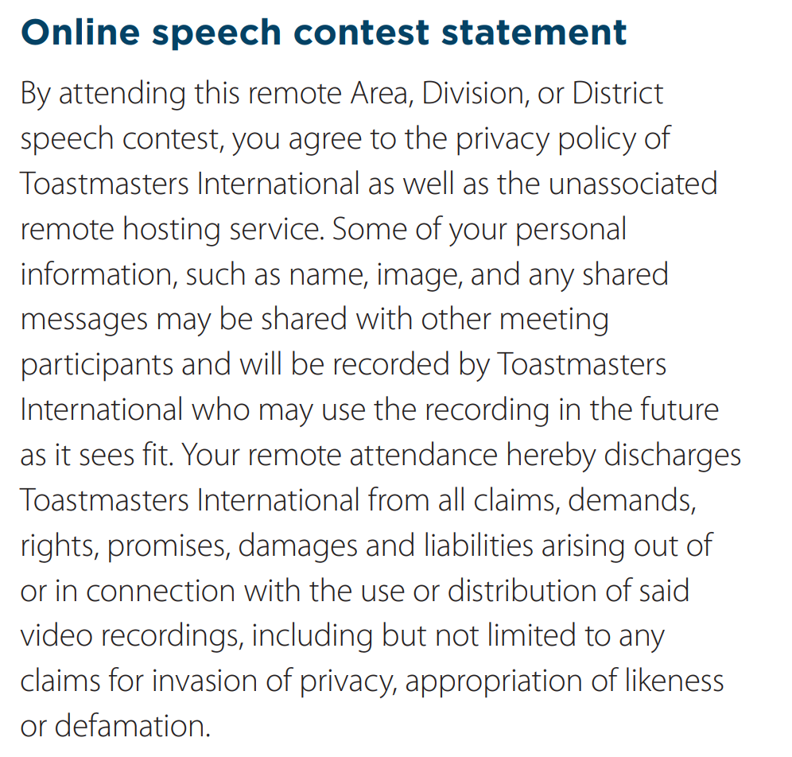

Script
Welcome everyone to the Toastmasters Southern Division Contest for the International and Evaluation online contest!
We are excited and grateful for your presence here with us today!
Today’s competition is an opportunity for our Toastmaster members to show case the skills they’ve learned throughout their Toastmasters journey.
If you have not displayed the online speech contest statement visible to all it must be read – suggest doing it here.
In order to ensure that our competition is run smoothly, orderly, and fairly, there are some rules that we must all adhere to:
All videos must be turned off for the duration of the contest, except for the one currently speaking and the timer. This allows the timer to be clearly visible at all times to the contestants when they are speaking.
All audio must be turned off for the duration of the competition, except when you are nominated to speak. This will minimize distraction and disruption during the contest proper.
If you violate rules 1 or 2, Zoom Master 1, will turn off your video and audio and give you a warning via the Zoom chat message. A repeat violation will result in you being ejected from the meeting and you will not be allowed back inside
The judges must keep their cameras off and mics muted for the WHOLE contest.
Please use Zoom chat which is set to Host-Only to send important messages relevant to the competition to Zoom Master 1, who will pass it on to the relevant parties.
Do enjoy the speeches in today’s competition. Feel free to laugh heartily, while still being on mute!

