TOASTMASTERS INTERNATIONAL DISTRICT 17
INTERNATIONAL SPEECH CONTEST
CONTEST CHAIR SCRIPT TO CONTESTANTS
Online Contest 2021
This briefing can be conducted up to 24 hours prior to the contest using the platform (Zoom) that will be in use for the contest. (As per rule book).
This contest is in accordance with Toastmasters International Contest Rule Book 2020-2021and TI Online Speech Contest Best Practices 2020 – 2021 Toastmasters Contest Cycle
Before the Contestant Briefing
- Ensure the Timers are on-line for the contestant briefing to show timing colours and to be briefed on the process if there is an equipment failure.
- Ensure that you have a method to determine the speaking order (Random.org).
- Check all contestants are eligible to compete and that you have received the Eligibility and Originality forms.
- Check that you have received the speech titles and their completed Speech Contestants Profile (Bio) for conducting contestant interview.
- Ensure you have read the Item 479 from TI – Online Speech Contest Best Practice (this is recommended reading for all role players and contestants).
- Seek advice from Chief Judge for timing (suggested 3 minutes) of contestant reconnection in case of technology failure.^{#2}
- Ensure you have participation certificates (provide to Zoom Master).
- Ensure you have winner certificates (provide to Zoom Master).
Contestant Briefing
Contestants welcome to the Area xx/ Division xx / District 17 International Speech Contest 2021.
We will now draw the speaking order. Draw the speaking order ^{#3}- using the method chosen.
Contestant number one will be
Contestant number two will be
Contestant number three will be
Contestant number four will be
Contestant number five will be
Contestant number six will be
Send speaking order to the Chief Judge and Zoom Master.
I will now like you to demonstrate your speaking area.
While all contestants will be speaking in their own space, using their own technology, the speaking area should be set to roughly the same size for each contestant. When setting speaking area, the goal is to maximize the view of the contestants without sacrificing audio quality. (TI Item 479 Online Speech Contest Best Practice).
District contest only: Ensure rule book criteria are met regarding lighting audio and speaking area.
Once the speaking areas are roughly the same size, you can continue with the briefing.
You will need to advise the Chief Judge on how the speaking area was defined, for them to pass onto the other judges.
Please advise if you are using props.^{#7}
Contestants Video and Microphone
Your video and microphone is to remain off / on mute unless you are speaking or unless asked by the Contest Chair to switch on.
Protests
Protests are limited to eligibility, originality and referencing another contest speaker’s speech. Protests need to be lodged with myself. If you wish to lodge a protest, please text/sms me prior to the announcement of the results. Ensure contestants have your phone number.
As a protestor you will be called to the Judges room to show evidence of your protest. The contestant will be interviewed by the Judges to determine if the protest will be upheld. The Judges will determine if the protest is valid.
Disqualifications
Contestants will be disqualified if they speak less than 4 minutes 30 seconds or more that 7 minutes 30 seconds. (Allowing for system failure corrections plus 30 second allowance).
Please ensure you know how to pin the Timer or hide non-video participants. Provide details on this if necessary. ^{#8}
Timer, could we please have a display of the timing lights. Timer to demonstrate timing lights while Contest Chair reads the following.
Timing will be begin with the first definite verbal or non-verbal communication. The green signal will be displayed at 5 minutes and remain on until the 6 minute mark and be replaced by an amber signal which will remain on until the 7 minute mark and be replaced by a red signal. This will remain on until the conclusion of your speech.
Thank you, Timer.
When you are introduced for your speech, I will ask you to respond verbally to ensure that your mic is on and that you can see the Timer.
I will then introduce you in the format - your name, your speech title, your speech title and your name again. At this point you should start your presentation without delay.
On completion of your speech, please turn off your video and microphone.
If your (contestant’s) system drops out during your presentation:
- Timers, will take note of the time, then time a maximum of 3 minute for you to regain your connection.
- Timer 1 will display the neutral colour while you attempt to reconnect. At the conclusion of the three minutes, if you have not reconnected, the Timer will display the red.
- If you do reconnect within the specified time, the Timer will change the timing colour to the colour it was on when you dropped out and continue timing as per the standard timing convention.
- You will need to resume your speech where you left off. I will provide you with the last word(s) that I recall when you were disconnected^{#6}. You can then recommence your speech and the timing will restart from then.
- You will also be given an extra 30 seconds to your overall time, before being disqualified for going over time.
- If you drop out for a second time your speech will be considered concluded and the time will be recorded at that point.
If the timing signal system (Timer 1) drops out during your presentation look for Timer 2 who will take over the timing system.
You may record your own speeches, please ensure that this recording can be done without substantially disrupting the contest.
District only: The Zoom Master has been instructed to record all speeches.
On completion of the contest you will be asked to turn your video on. You will be presented with your participation certificate and then I will conduct interviews using the information on your Bio. During this time, please turn your microphone off unless answering a question.
This concludes the briefing. Do you have any questions?

This is not to be read to the Contestants, and is only included for the information of the Contest Chair, Chief Judge and other interested parties.
Explanations of Script:
Non spoken information and explanations in red
Information based on choice is in green.
Contestant introduction information to be repeated for all contestants in purple.

References and TI Best Practice Details:
The following are to be read in conjunction with Toastmasters International Speech Contest Rules and TI Online Speech Contest Best Practices 2020 – 2021 Toastmasters Contest Cycle
#1 Contestant eligibility
Eligibility form is to be downloaded by contestant, signed, photographed, and sent to the contest chair and Chief Judge from their personal message service which will identify them as the sender. For the International speech contest:- already competed 6 Competent Communicator speeches or have certificates for completing level 1 and level 2 of any path.
#2 Chief Judge to determine time duration for contestant to reconnect. For consistency 3 minutes have been recommended for this speech cycle.
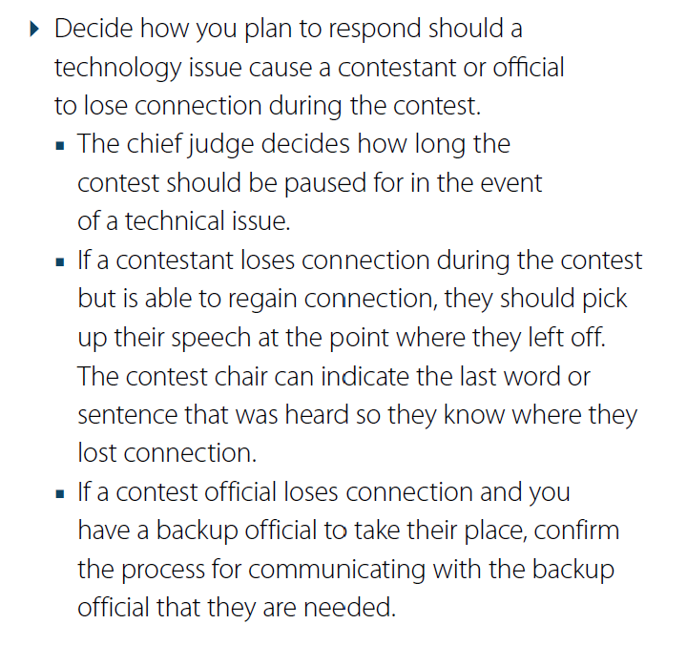
#3 Draw random selection
Contest Chair selects using “Random.org” Random .org will be activated, using the again button until each contestant number appears (There is often duplicated numbers in sequences) creating the speaking order.
Contestants are assigned numbers using alphabetical sequence of their family or surname.

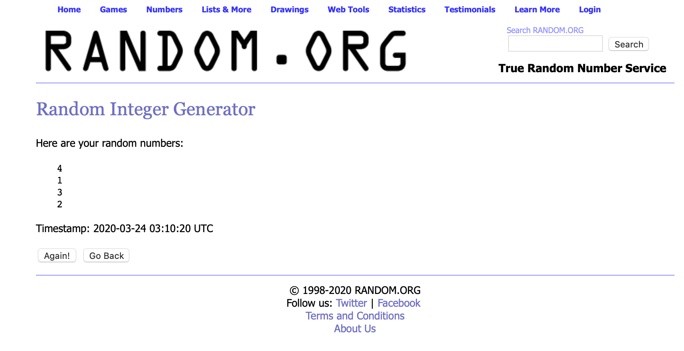
#4 Judges eligibility
Judges eligibility form is to be downloaded by the judge, completed, signed, photographed, and sent to the Chief Judge from an electronic source that identifies who has submitted the form.
Judges are to download the judging form, complete their responsibility, sign the form, photograph the lower portion of the judging form, and send it to all tally counters (plus the Chief Judge to confirm all tallys have been submitted) from an electronic source that identifies who has submitted the form.
B. To be a Chief Judge, voting judge, or tiebreaking judge at a Toastmasters speech contest, you must meet all eligibility requirements identified below.
- At a club contest, be a paid member.
- At an Area, Division, or District contest:
a) Be a paid member for a minimum of six (6) months.
b) Have completed a minimum of six (6) speech projects in Competent Communication or earned certificates of completion in Levels 1 and 2 of any path in the Toastmasters Pathways learning experience.
→ 1. Only members who joined Toastmasters prior to the rollout of Pathways in their region can apply speeches from the Competent Communication manual to eligibility for judging.
c) Be physically present at the contest for which you are serving.
#5 Tally counters
Tally counters are to ensure all ballots have been received. Inform the Chief Judge you have received all ballots. Ensure all ballots have the judges name and signature before commencing your record. Complete the tally counter sheet, sign, photograph, which is sent to the Chief Judge from their personal message service which will identify them as the sender)
Chief Judge to ensure all tally counters have the same score. Complete the notification of winner sheet, photograph it and send to Contest Chair from their personal message service which will identify them as the sender
#6 Webcams turned off Microphones muted at all times.
Webcams can slow down internet band width and distract some contestants.
Although laughter and verbal reactions from audience members are often welcome in a speech contest microphones in an online speech contest setting will also pick up distracting background audio.
Contest interviews do not need to be extensive. The TI documents include the following statement. If used remember to advise your audience (everyone) what will happen.
■ Pause the contest and end the online meeting after the final contestant interview. Then restart the meeting and reconvene when results have been determined.
#7 Props
Contestants who plan to use props (including any sort of electronic devices) must notify the contest chair prior to the contest.

#8 Pin Timer
Using the 3 small dots at the top of your photo pin timer. At the bottom of the screen there is the word Video and a small arrow along side it . Click on the arrow and pin the timer
Ipad double tap screen.

