TOASTMASTERS INTERNATIONAL DISTRICT 17
INTERNATIONAL SPEECH CONTEST
CONTEST CHAIR SCRIPT TO AUDIENCE
Online Contest 2021
Members and Guests, welcome to the Area xx/ Division xx / District 17 International Speech Contest 2021.
The purpose of today’s contest is:
- To provide an opportunity for speakers to improve their speaking abilities and to recognise the best as encouragement to all.
- To provide an opportunity to learn by observing the more proficient speakers who have benefited from their Toastmasters training.
This is an online contest being conducted on Zoom. (specify if other platform in use)
All participants and officials have been briefed on the requirements and given an opportunity to previously trial online tools or programs.
Audience, please ensure that you are muted and that your video is off. You must remain muted and with video off for the entire contest.^{#6}
Toastmasters International have directed the following speech contest statement be read at the commencement of all online speech contests.
Online speech contest statement
By attending this remote Area, Division, or District speech contest, you agree to the privacy policy of Toastmasters International as well as the unassociated remote hosting service. Some of your personal information, such as name, image, and any shared messages may be shared with other meeting participants and will be recorded by Toastmasters International who may use the recording in the future as it sees fit. Your remote attendance hereby discharges Toastmasters International from all claims, demands, rights, promises, damages and liabilities arising out of or in connection with the use or distribution of said video recordings, including but not limited to any claims for invasion of privacy, appropriation of likeness or defamation.
All Contestants have confirmed their eligibility in writing.^{#1}
Contestants and judges are aware of the speaking area.^{#2}
The contest timing, and operation of the timing lights have been explained to the contestants.
All contestants and judges have been briefed on the rules of the contest.
Area / Division Level Only: The winner of today’s contest will progress to the Division/District contest to be held on _________________________.
District Level Only: In accordance with the rules this district level speech contest will be recorded to enable the winner to progress to the International Speech contest Regional Quarter Finals.
There shall be no photography or recording of this speech permitted during the speech unless prior authorisation has been given. Contestant may record their own speech.
Each contestant will present a 5 to 7 minute speech on a subject of their choosing.
The contestants have drawn the speaking order ^{#3} which as follows:-
Contestant number one will be
Contestant number two will be
Contestant number three will be
Contestant number four will be
Contestant number five will be
Contestant number six will be
Our Chief Judge today is …………………… (Chief Judge to display video.) please thank them.
Chief Judge, are we ready to proceed? (Chief Judge to unmute and respond. After response Chief Judge to mute and hide video.)
##Members and Guests, please welcome Contestant number one.
Contest Chair: To check your audio please tell us your name and if you can see the timer.”
Contestant to respond.
Our first contestant is Contestant’s name – speech title – speech title – name. No information beyond name and title to be announced
 | Name | Speech Title
Contestant 1
Contestant 2
Contestant 3
Contestant 4
Contestant 5
Contestant 6
As each Contestant concludes We will now have one minute silence for the judges to conclude their scores.
Timers please display the red background when 1 minute has elapsed.
After each speaker has concluded, wait for the signal from the Timer that one minute of silence has lapsed before proceeding. Then repeat from ## for all contestants.
After the last Contestant concludes We will now have silence until the Chief Judge confirms all ballots have been received.
Judges, please ensure that your ballot is valid by signing your name and listing the first three place-getters.^{#4}
Timers, please forward your report to the Chief Judge.
Allow 3 minutes for the Chief Judge to advised that all ballots have been received. If they have not, the Zoom Master is to move the Chief Judge and all voting judges (not Tie-Breaker) into a breakout room.
Once the Chief Judge has confirmed the ballots received or all voting judges and Chief Judge are in break out room, the Contest Chair can commence interviews.
Once the Chief Judge has confirmed with each judge that they have received the ballot, the judge can leave the breakout room. Once all judges have left, the Zoom Master can move the Tally Counters into the breakout room with the Chief Judge. ^{#5}
That concludes the International Speech contest.
When the Chief Judge returns.
Chief Judge do we have a result?
Chief Judge to announce any disqualifications for time without naming the disqualified contestant(s).
When results are to be announced, as per agenda.
The results for the Area / Division / District International Speech Contest are:
In third place is (name)
In second place is (name)
And to represent Area xx / Division xx / District 17 in the International Speech Contest please join with me in congratulating our first place winner …………………………..(name)

This is not to be read to the Audience, and is only included for the information of the Contest Chair, Chief Judge and other interested parties.
Explanations of Script:
Non spoken information and explanations in red
Information based on choice is in green.
Contestant introduction information to be repeated for all contestants in purple.

References and TI Best Practice Details:
The following are to be read in conjunction with Toastmasters International Speech Contest Rules and TI Online Speech Contest Best Practices 2020 – 2021 Toastmasters Contest Cycle

#1 Contestant eligibility
Eligibility form is to be downloaded by contestant, signed, photographed, and sent to the contest chair and Chief Judge from their personal message service which will identify them as the sender.
#2 Speaking Area
(Speaking area is the space visible by the camera. Contestants should not leave the camera view). All contestants should have a similar view. One standing (preferred) one seated is not allowed. All should use a webcam and microphone plus be familiar with the rules regarding lighting as detailed in the rule book.
#3 Draw random selection
Contest Chair selects using “Random.org” Random .org will be activated, using the again button until each contestant number appears (There is often duplicated numbers in sequences) creating the speaking order.
Contestants are assigned numbers using alphabetical sequence of their family or surname.

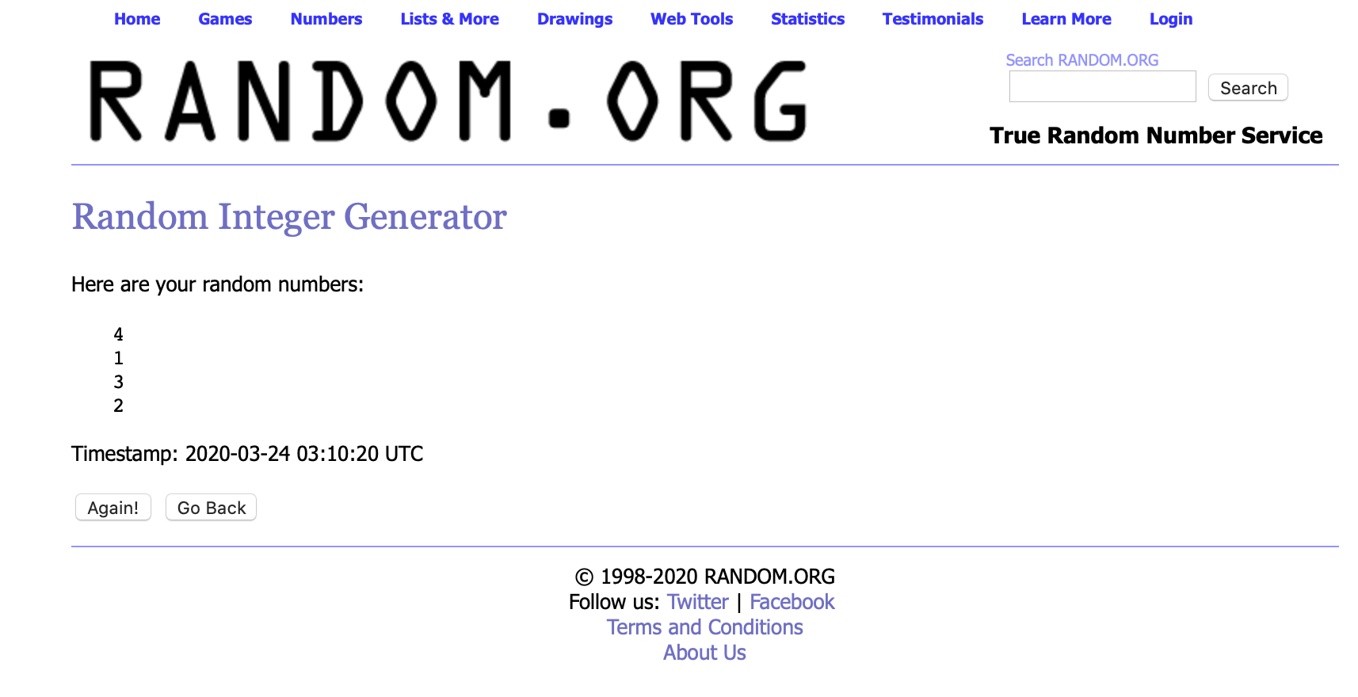
#4 Judges eligibility
Judges eligibility form is to be downloaded by the judge, completed, signed, photographed, and sent to the Chief Judge from an electronic source that identifies who has submitted the form
Judges are to download the judging form, complete their responsibility, sign the form, photograph the lower portion of the judging form, and send it to all tally counters (plus the Chief Judge to confirm all tallys have been submitted) from an electronic source that identifies who has submitted the form.
B. To be a Chief Judge, voting judge, or tiebreaking judge at a Toastmasters speech contest, you must meet all eligibility requirements identified below.
- At a club contest, be a paid member.
- At an Area, Division, or District contest:
a) Be a paid member for a minimum of six (6) months.
b) Have completed a minimum of six (6) speech projects in Competent Communication or earned certificates of completion in Levels 1 and 2 of any path in the Toastmasters Pathways learning experience.
→ 1. Only members who joined Toastmasters prior to the rollout of Pathways in their region can apply speeches from the Competent Communication manual to eligibility for judging.
c) Be physically present at the contest for which you are serving.
#5 Tally counters
Tally counters are to ensure all ballots have been received. Inform the Chief Judge you have received all ballots. Ensure all ballots have the judges name and signature before commencing your record. Complete the tally counter sheet, sign, photograph, which is sent to the Chief Judge from their personal message service which will identify them as the sender)
Chief Judge to ensure all tally counters have the same score. Complete the notification of winner sheet, photograph it and send to Contest Chair from their personal message service which will identify them as the sender
#6 Webcams turned off Microphones muted at all times.
Webcams can slow down internet band width and distract some contestants.
Although laughter and verbal reactions from audience members are often welcome in a speech contest microphones in an online speech contest setting will also pick up distracting background audio.
Contest interviews do not need to be extensive. The TI documents include the following statement. If used remember to advise your audience (everyone) what will happen.
■ Pause the contest and end the online meeting after the final contestant interview. Then restart the meeting and reconvene when results have been determined.

